**Academic Curriculum Vitae**

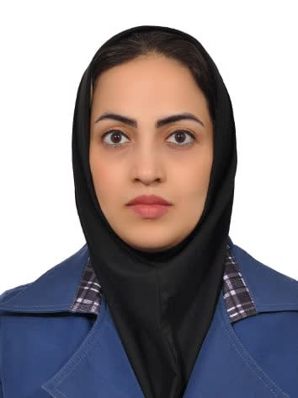

**Saedeh,zeynalzad, Bsc, MScN**

**Teacher of Department of Psychiatric Nursing and Management**

Address: School of Nursing and Midwifery, Shahid Beheshti University of Medical Sciences, Tehran, Iran.

**E-mail:** [saedehzeynalzadeh@yahoo.com](mailto:saedehzeynalzadeh@yahoo.com)

**Research interests:**

Mental disorders of children and adolescents

Addiction nursing

Policy making in the field of social damages

|  |
| --- |
| **Education** |

|  |  |  |  |
| --- | --- | --- | --- |
| **Year** | **Degree** | **Institution** | **Location** |
| 2013 | Bachelor of Nursing | Shahid Beheshti University of Medical Sciences | Tehran, Iran |
| 2017 | Master of Nursing  By winning the first place in the entire course (18 grade point average) | Tehran University of Medical Sciences | Tehran, Iran |
| 2021 | Student of PhD in nursing | Isfahan University of Medical Sciences | Isfahan, Iran |

|  |
| --- |
| **Research- Publications** |

1. **Zeighami R, Sarichloo M E, Hosseinkhani Z****, Zeynalzadeh S. The Effect of Parent-Child Interaction Therapy on Separation Anxiety in 3-6-Year-old Children of Nurses. Iran J Psychiatry Behav Sci. 2022;16(2): e111302. https://doi.org/10.5812/ijpbs-111302.**
2. **Zeighami R, Sarichloo ME, Hosseinkhani Z, Zeynalzad S. Anxiety disorder of 3-6-year-old children. J Nurs Midwifery Sci [serial online] 2021 [cited 2023 Oct 15]; 8:79-84. Available from: https://www.jnmsjournal.org/text.asp?2021/8/2/79/315416Tayyar-Iravanlou F,**
3. **Zeighami R, Zeynalzadeh S. "The role of the family in the prevention of children's addiction: a review" as a speech in the "First International Conference on Psychology, Educational Sciences and Social Studies"**
4. **Zeighami R, Zeynalzadeh S "Parent-child therapeutic interaction: a review" as a speech at the 4th International Congress of Psychological Sciences in Georgia**